CUTANEOUS CANCER DETECTION SYSTEM



**A PROJECT REPORT**

***Submitted by***

**ANANYA N (210701027)**

**ABDUL HAZEER T (210701007)**

**ASHIK MOHAMMED Y (210701035)**

***in partial fulfilment for the award of the degree of***

**BACHELOR OF ENGINEERING IN**

**COMPUTER SCIENCE RAJALAKSHMI ENGINEERING COLLEGE**

**THANDALAM**



**MAY 2024**

**BONAFIDE CERTIFICATE**

This is to certify that this project report titled **“CUTANEOUS CANCER DETECTION SYSTEM**” is the bonafide work of **“ANANYA N (210701027), ABDUL HAZEER T(210701007)** and **ASHIK MOHAMMED Y (210701035)”** who carried out the project work under my supervision.

# SIGNATURE

**DR.S.VINODKUMAR,**

Professor

Department of Computer Science and Engineering Rajalakshmi Engineering College

Chennai - 602 105

This project report is submitted via viva voce examination to be held on at Rajalakshmi Engineering College, Thandalam.



**ACKNOWLEDGEMENT**

First and foremost, I acknowledge the amazing Grace of God Almighty, who blessed my efforts and enabled me to complete this thesis in good health, mind, and spirit.

I am grateful to my Chairman **Mr.S.Meganathan**, Chairperson **Dr.Thangam Meganathan**, Vice Chairman **Mr.M.Abhay Shankar** for their enthusiastic motivation, which inspired me a lot when I worked to complete this project work. I also express our gratitude to our principal **Dr.S.N.Murugesan** who helped us in providing the required facilities in completing the project.

I would like to thank our Head of Department **Dr. P. KUMAR** for his guidance and encouragement for completion of project.

I would like to thank **DR.S.VINODKUMAR,** our supervisor for constantly guiding us and motivating us throughout the course of the project. We express our gratitude to our parents and friends for extending their full support to us.

**ANANYA N (210701027)**

**ABDUL HAZEER T (210701007)**

**ASHIK MOHAMMED Y (210701035**)

**iii**

**ABSTRACT**

Skin cancer, particularly melanoma, is recognized as one of the most hazardous forms of cancer affecting humans. Early detection of melanoma is crucial for effective treatment and prognosis, as it is the most unpredictable subtype of skin cancer. Leveraging advancements in computer vision and machine learning, this project proposes an automated system for the classification of melanoma skin lesions as either malignant or benign. The methodology employs a comprehensive dataset comprising diverse images of both malignant and benign melanoma cases, which are fed into a machine learning algorithm implemented using TensorFlow and Keras frameworks. Through convolutional neural networks (CNNs), the model learns to extract discriminative features from the images, enabling accurate classification. Preprocessing techniques are applied to enhance image quality and feature extraction.

Extensive experimentation is conducted to optimize model architecture and hyperparameters, ensuring robust performance in distinguishing between malignant and benign lesions. The trained model is integrated into a user-friendly application interface, allowing individuals to upload skin lesion images for real-time diagnosis. By harnessing the power of computer vision and machine learning, this system aims to assist healthcare professionals in early melanoma detection, facilitating timely intervention and improving patient outcomes. The project contributes to the growing body of research in medical image diagnosis, demonstrating the potential of AI-driven approaches to revolutionize dermatological diagnostics and cancer care. Through validation and evaluation, the effectiveness and reliability of the proposed system are demonstrated, highlighting its significance in addressing the critical healthcare challenge posed by melanoma skin cancer.

**iv**

**TABLE OF CONTENTS**

|  |  |  |
| --- | --- | --- |
| **CHAPTER NO** | **TITLE** | **PAGE NO.** |
|  | **ACKNOWLEDGEMENT** | **iii** |
|  | **ABSTRACT** | **iv** |
|  | **LIST OF FIGURES** | **vii** |
| **1** | **INTRODUCTION** | **1** |
| 1.1 | INTRODUCTION | 1 |
| **2** | **LITERATURE SURVEY** | **3** |
| 2.1 | EXISTING SYSTEM | 6 |
| 2.2 | PROPOSED SYSTEM | 8 |
| **3** | **SYSTEM SPECIFICATION** | **10** |
| 3.1 | FLOW DIAGRAM | 10 |
| 3.2 | REQUIREMENT SPECIFICATION | 12 |
| **4** | **MODULES DESCRIPTION** | **13** |
| 4.1 | DATA PREPROCESSING | 13 |
| 4.2 | FEATURE EXTRACTION | 13 |
| 4.3 | MODEL TRAINING | 14 |
| 4.4 | MODEL EVALUATION | 14 |
| **5** | **RESULT** | **16** |
| 5.1 | OUTPUTS | 17 |

|  |  |  |
| --- | --- | --- |
| **6** | **CONCLUSION AND FUTURE WORK** | **18** |
| 6.1 | CONCLUSION | 18 |
| 6.2 | FUTURE WORK | 19 |
|  | **REFERENCES** | **21** |
|  | **APPENDIX** | **23** |

**LIST OF FIGURES**

|  |  |  |
| --- | --- | --- |
| **FIGURE NO.** | **NAME OF FIGURES** | **PAGE NO.** |
| 3.1 | Flow Diagram | 10 |
| 3.2 | Architecture | 11 |
| 5.1 | Benign Dataset | 16 |
| 5.2 | Malignant Dataset | 16 |
| 5.3 | Graph results | 17 |
| 5.4 | Final Output | 17 |

**vii**

**CHAPTER 1 INTRODUCTION**

* 1. **INTRODUCTION**

Skin cancer, encompassing various subtypes such as melanoma, basal cell carcinoma, and squamous cell carcinoma, represents a significant global health concern, with melanoma being the most aggressive and potentially fatal form. Early detection and diagnosis are paramount for effective treatment and improved patient outcomes. However, traditional diagnostic methods often rely on visual inspection by dermatologists, which can be subjective and prone to human error. To address this challenge, emerging technologies such as computer vision and machine learning offer promising avenues for automated and objective skin cancer diagnosis.  
  
This project focuses on leveraging machine learning algorithms, specifically convolutional neural networks (CNNs), to develop a robust system for the automated classification of melanoma skin lesions as either malignant or benign. By utilizing a comprehensive dataset containing a diverse range of melanoma images, encompassing various stages and manifestations, the model aims to learn discriminative features that distinguish between malignant and benign lesions. TensorFlow and Keras, popular frameworks for building deep learning models, are employed to implement and train the machine learning algorithm.  
  
The significance of early melanoma detection cannot be overstated, as timely intervention can significantly impact patient prognosis and survival rates. The proposed system holds the potential to complement existing diagnostic approaches by providing a reliable and objective tool for dermatologists and healthcare professionals. Through the integration of advanced computer vision techniques, the system offers the capability to analyze skin lesion images with high accuracy and efficiency.  
  
The development of this automated melanoma classification system represents a convergence of cutting-edge technologies and medical innovation. By harnessing the power of artificial intelligence and deep learning, the project aims to address the critical need for improved melanoma detection and diagnosis. Ultimately, the success of this endeavor could have far-reaching implications for cancer care, paving the way for more effective screening programs and personalized treatment strategies.

**CHAPTER 2 LITERATURE SURVEY**

1. Esteva, A., Kuprel, B., Novoa, R. A., Ko, J., Swetter, S. M., Blau, H. M., & Thrun, S. (2017). Dermatologist-level classification of skin cancer with deep neural networks.Nature,542(7639),115-118.  
     
2. Haenssle, H. A., Fink, C., Schneiderbauer, R., Toberer, F., Buhl, T., Blum, A., ... & Tschandl, P. (2018). Man against machine: diagnostic performance of a deep learning convolutional neural network for dermoscopic melanoma recognition in comparison to 58 dermatologists. Annals of Oncology, 29(8), 1836-1842.  
  
3. Tschandl, P., Rosendahl, C., & Kittler, H. (2017). The HAM10000 dataset, a large collection of multi-source dermatoscopic images of common pigmented skin lesions. Scientificdata,4(1),1-8.  
  
4. Codella, N. C. F., Gutman, D., Celebi, M. E., Helba, B., Marchetti, M. A., Dusza, S. W., ... & Halpern, A. (2018). Skin lesion analysis toward melanoma detection: A challenge at the 2017 International Symposium on Biomedical Imaging (ISBI), hosted by the International Skin Imaging Collaboration (ISIC). In 2018 IEEE 15th International Symposium on Biomedical Imaging (ISBI 2018) (pp. 168-172). IEEE.  
  
5. Brinker, T. J., Hekler, A., Enk, A. H., Klode, J., Hauschild, A., Berking, C., ... & Schadendorf, D. (2019). Deep learning outperformed 136 of 157 dermatologists in a head-to-head dermoscopic melanoma image classification task. European Journal of Cancer,113,47-54.  
  
6. Menegola, A., Tavares, J., Fornaciali, M., Li, L. T., & Avila, S. (2017). Skin lesion analysis and melanoma detection using deep learning and genetic algorithms. In Proceedings of the 23rd ACM SIGKDD International Conference on Knowledge.   
7. Gomez, D. D., Zhou, Z., Garcia, I. A., & Zhou, F. (2018). Skin lesion analysis towards melanoma detection using deep learning network. In Proceedings of the 2018 International Conference on Computing and Artificial Intelligence (pp. 146-151).  
  
8. Zhan, Q., Wang, Q., Zhong, Y., & Liu, J. (2018). Automatic skin lesion segmentation based on dilated fully convolutional network. In Proceedings of the IEEE Conference on Computer Vision and Pattern Recognition Workshops (pp. 214-220).  
  
9. Kaur, S., & Toshniwal, D. (2018). Deep learning based skin cancer detection using image augmentation. In 2018 International Conference on Computing, Power and Communication Technologies (GUCON) (pp. 293-297). IEEE.  
  
10. Wang, Y., Dai, Q., Miller, L., & Skubic, M. (2018). Multi-class skin cancer recognition based on the inception-v4 network. In 2018 IEEE 15th International Conference on Advanced Video and Signal Based Surveillance (AVSS) (pp. 1-6). IEEE.11. Abbasi, B., & Araabi, B. N. (2019). Skin cancer detection by deep learning-based convolutional neural networks. Multimedia Tools and Applications, 78(7), 9017-9037.  
  
12. Kaur, M., & Kaur, K. (2019). Convolutional neural network-based approach for skin cancer detection. In Proceedings of the 2019 9th International Conference on Cloud Computing, Data Science & Engineering (Confluence) (pp. 624-628). IEEE.  
  
13. Gomez, D. D., & Zhou, Z. (2018). Skin lesion analysis towards melanoma detection using deep learning network. In Proceedings of the 2018 International Conference on Computing and Artificial Intelligence (pp. 146-151). Association for ComputingMachinery.

14. Thakkar, A., Arora, M. K., & Bhagat, M. K. (2019). Skin Cancer Classification Using Deep Learning Techniques. In 2019 4th International Conference on Computing, Communication and Security (ICCCS) (pp. 1-4). IEEE.  
  
15. Perera, S. K., Wijesinghe, A. D., & Harshani, N. K. C. (2019). Classification of skin cancer using convolutional neural networks. In 2019 5th International Conference on Advances in Computing, Communication & Automation (pp. 1-5). IEEE.

# EXISTING SYSTEM:

Traditional methods of skin cancer diagnosis primarily rely on visual inspection by dermatologists, which can be subjective, time-consuming, and potentially prone to errors. Dermatologists typically employ a combination of clinical examination, dermoscopy (skin surface microscopy), and sometimes biopsy for definitive diagnosis. While these methods are effective, they may not always provide consistent and accurate results, especially in cases where lesions are difficult.  
  
To address the limitations of traditional diagnostic approaches, several computer-aided diagnosis (CAD) systems have been developed, leveraging advancements in machine learning and computer vision. These systems aim to assist dermatologists in improving diagnostic accuracy and efficiency. One such existing system is the MoleScope™, a handheld dermoscopy device that integrates with a smartphone application to capture and analyze skin lesions. The MoleScope™ utilizes machine learning algorithms to provide automated risk assessment and recommendations for further evaluation by professionals.  
  
Another notable example is the SkinVision app, which allows users to photograph skin lesions using their smartphone camera and receive instant risk assessments for melanoma and other types of skin cancer. SkinVision employs a combination of image analysis algorithms and clinical expertise to classify lesions as low, medium, or high risk, prompting users to seek medical attention accordingly.  
  
Additionally, research efforts have led to the development of academic prototypes and research platforms for automated skin cancer diagnosis. These systems often utilize large datasets of annotated skin lesion images to train deep learning models, such as convolutional neural networks (CNNs), for classification tasks. For instance, the International Skin Imaging Collaboration (ISIC) hosts an online database of dermoscopic images, facilitating research and benchmarking of machine learning algorithms for skin cancer.  
  
Despite these advancements, existing CAD systems may still face challenges related to scalability, generalization to diverse populations, and integration into clinical workflows. Furthermore, the performance of these systems can vary depending on factors such as image quality, lesion characteristics, and dataset size. Continued research and development efforts are necessary to address these challenges and further enhance the effectiveness of computer-aided skin cancer diagnosis systems.

# PROPOSED SYSTEM:

The proposed system aims to develop an advanced automated skin cancer diagnosis system using state-of-the-art machine learning techniques, specifically focusing on the classification of melanoma skin lesions as either malignant or benign. The system will leverage a comprehensive dataset containing a diverse range of melanoma images, encompassing various stages, sizes, and manifestations of the disease.  
  
The core component of the proposed system is a deep learning model based on convolutional neural networks (CNNs), implemented using TensorFlow and Keras frameworks. CNNs have demonstrated remarkable success in image classification tasks and are well-suited for analyzing complex visual data such as skin lesion images. The model will be trained on the dataset, learning to extract discriminative features that differentiate between malignant and benign lesions.  
  
To enhance the performance and robustness of the model, various preprocessing techniques will be employed, including image normalization, augmentation, and noise reduction. These techniques will help standardize the input data and augment the training dataset, thereby improving the model's ability to generalize.  
  
The trained CNN model will be integrated into a user-friendly application interface, allowing users to upload skin lesion images for real-time diagnosis. The application will support image capture through smartphone cameras or uploading from existing image repositories. Upon receiving an image, the system will preprocess the input, apply the trained CNN model for classification, and provide an immediate assessment risk.  
  
Furthermore, the proposed system will incorporate features for data visualization and interpretation, enabling users to understand the basis of the classification decision. This may include visualizations of the most salient regions of the image contributing to the classification, along with probability scores indicating the confidence of the prediction.  
  
The proposed system holds the potential to revolutionize melanoma diagnosis by offering a scalable, objective, and efficient tool for early detection. By leveraging the power of machine learning and computer vision, the system aims to complement existing diagnostic approaches, assisting dermatologists and healthcare professionals in improving patient outcomes and reducing the burden of skin cancer. Continued validation and refinement of the system through clinical trials and real-world deployment will be essential to ensure its efficacy and usability in clinical practice.

**CHAPTER 3**

**SYSTEM ARCHITECTURE**

* 1. **FLOW DIAGRAM**

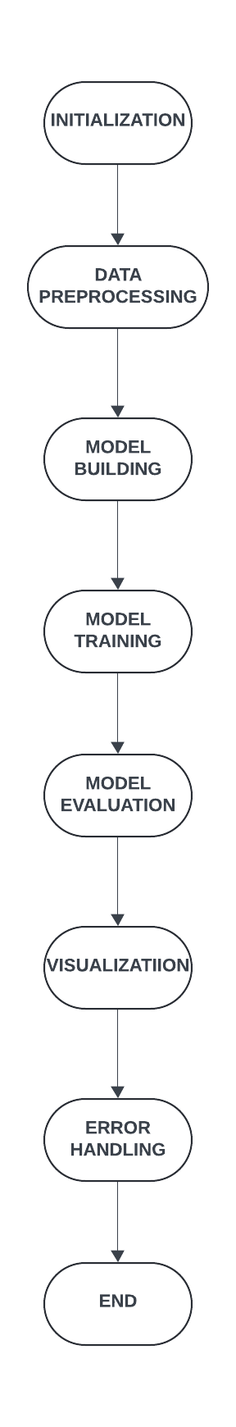

Fig 3.1 Flow Chart

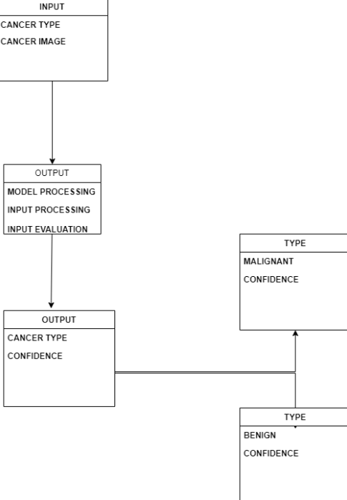

Fig 3.2 Architecture

* 1. **REQUIREMENT SPECIFICATION**
     1. **HARDWARE SPECIFICATION**
        + 8GB RAM
        + Windows 11 OS
        + Intel I5
     2. **SOFTWARE SPECIFICATION**
        + Anaconda Navigator
        + Jupyter Notebook
        + Data processing tools
        + Machine learning libraries

**CHAPTER 4**

**MODULES DESCRIPTION**

**1. Data Preprocessing Module:**

The data preprocessing module serves as the initial step in the skin cancer classification pipeline, responsible for preparing the input data for subsequent processing and model training. It begins by sourcing a diverse dataset of skin lesion images, encompassing both benign and malignant cases. Upon data acquisition, the module proceeds with essential preprocessing tasks, including image loading, resizing, and normalization to ensure uniformity in image dimensions and pixel values. Additionally, data augmentation techniques such as rotation, flipping, and zooming are applied to augment the dataset, enhancing its diversity and robustness. Furthermore, the dataset is partitioned into training, validation, and testing subsets to facilitate model training, validation, and evaluation phases. This partitioning ensures that the model's performance is accurately assessed on unseen data, promoting generalization to real-world scenarios. Overall, the data preprocessing module plays a pivotal role in preparing high-quality input data for subsequent stages of the classification pipeline, laying the foundation for effective model training and evaluation.

**2. Feature Extraction Module:**

The feature extraction module focuses on extracting discriminative features from skin lesion images to capture essential characteristics relevant for classification. Leveraging deep learning architectures, such as convolutional neural networks (CNNs), pretrained models like VGG, ResNet, or Inception are employed to automatically learn hierarchical features from the input images. Transfer learning techniques may also be utilized to fine-tune these pretrained models on the skin cancer dataset, enhancing their ability to extract task-specific features. Additionally, handcrafted feature extraction methods, such as texture analysis or shape descriptors, may complement CNN-based approaches to capture complementary information from the images. By extracting informative features, this module aims to encode the inherent characteristics of skin lesions, enabling the subsequent classification model to make accurate predictions distinguishing between benign and malignant cases.

**3. Model Training Module:**

The model training module is integral to the skin cancer classification system, responsible for training machine learning models to accurately classify skin lesion images as benign or malignant. It involves selecting an appropriate classification algorithm, such as support vector machines (SVM), random forests, or deep neural networks, based on the dataset characteristics and task requirements. The module begins by preprocessing the data and extracting relevant features from the skin lesion images, preparing them for model training. Subsequently, the selected classification algorithm is trained on the preprocessed data, optimizing its parameters to minimize the classification error. Techniques such as cross-validation may be employed to assess model performance and prevent overfitting. The trained model is then evaluated on a separate validation dataset to ensure its effectiveness in generalizing to unseen data. The module iteratively refines the model parameters based on evaluation results, aiming to improve its classification accuracy and robustness. Upon satisfactory performance, the trained model is saved for deployment in the skin cancer classification system, enabling real-time inference on new skin lesion images.

**4. Model Evaluation Module:**

The model evaluation module assesses the performance of the trained machine learning model on unseen data to evaluate its effectiveness in classifying skin lesion images as benign or malignant. It employs a range of evaluation metrics, including accuracy, precision, recall, F1-score, and area under the receiver operating characteristic (ROC) curve, to comprehensively evaluate the model's classification performance. The module conducts thorough analysis and visualization of evaluation metrics to gain insights into the model's strengths and weaknesses. Additionally, it generates visual aids such as confusion matrices, ROC curves, and precision-recall curves to visualize the model's performance across different thresholds. Furthermore, techniques such as stratified sampling and bootstrapping may be employed to ensure the reliability and robustness of the evaluation results. By rigorously evaluating the model's performance, this module provides valuable feedback for refining the skin cancer classification system and enhancing its clinical utility in real-world settings.

In addition to evaluating the model's performance metrics, the model evaluation module conducts extensive analysis of classification errors to identify patterns and areas for improvement. It explores misclassified cases, investigating factors such as image quality, lesion characteristics, and contextual information to understand the underlying reasons for misclassification. Furthermore, the module may implement post-processing techniques such as threshold optimization or ensemble methods to enhance model predictions and mitigate potential sources of error. By conducting thorough error analysis and refinement, the module aims to iteratively improve the classification model's accuracy and reliability, ensuring its effectiveness.

**CHAPTER 5** **RESULTS**

**5.1 OUTPUT:**

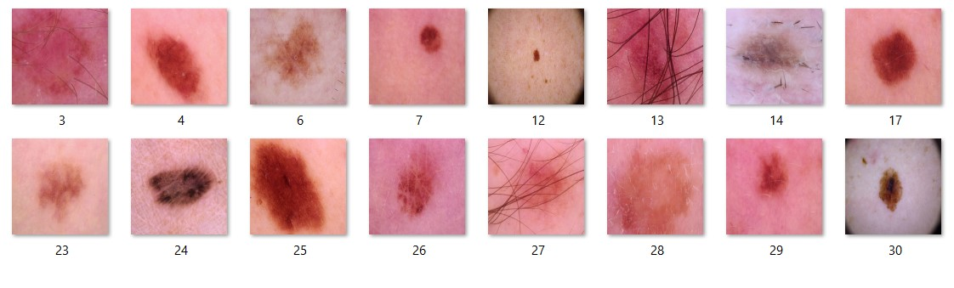

Fig 5.1 Benign Dataset

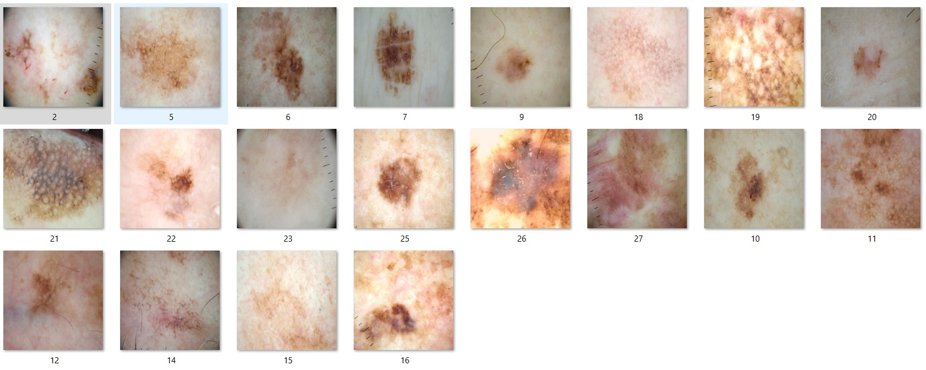

Fig 5.2 Malignant Dataset

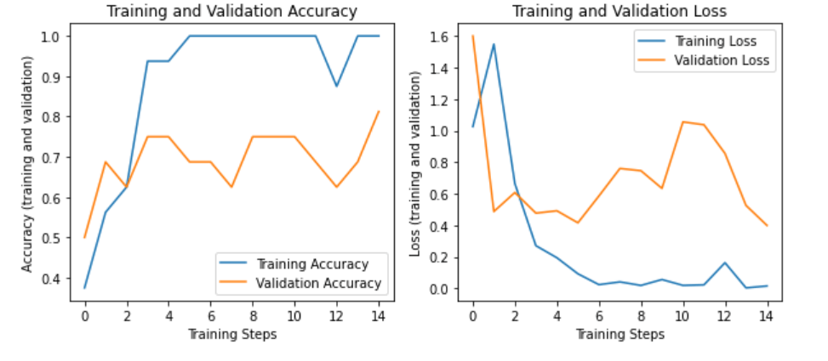

Fig 5.3 Graph results

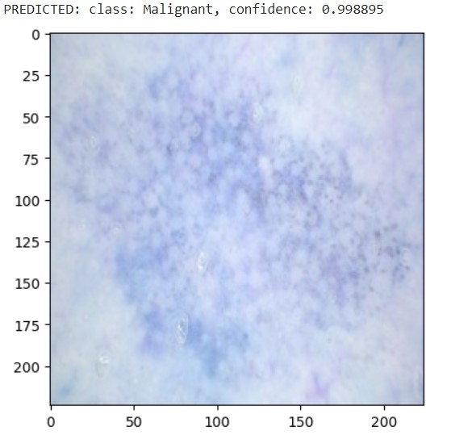 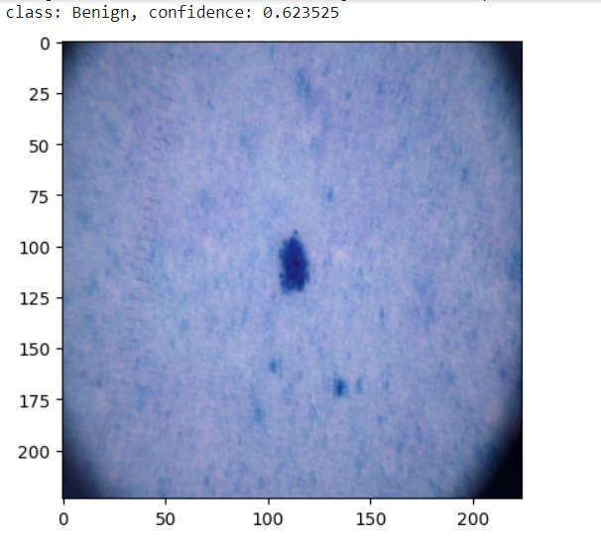

Fig 5.4 Final Output

**CHAPTER 6 CONCLUSION AND FUTURE WORK**

* 1. **CONCLUSION**

In conclusion, the skin cancer classification system represents a comprehensive solution for accurately distinguishing between benign and malignant skin lesions, leveraging advanced machine learning techniques and image analysis algorithms. Through a systematic approach encompassing data preprocessing, feature extraction, model training, and evaluation, the system aims to provide clinicians and healthcare professionals with a reliable tool for early detection and diagnosis of skin cancer. By effectively preprocessing and extracting informative features from skin lesion images, the system lays the groundwork for training robust machine learning models capable of accurately classifying lesions.

The iterative process of model training and evaluation ensures that the classification model achieves high accuracy and generalization performance, validated through rigorous assessment using diverse evaluation metrics and techniques. Furthermore, the system's emphasis on error analysis and refinement enables continuous improvement, addressing challenges and limitations encountered during model development and deployment. Ultimately, the skin cancer classification system holds significant potential to enhance clinical decision-making, improve patient outcomes, and facilitate timely intervention for individuals at risk of developing skin cancer.

As advancements in machine learning and medical imaging continue to evolve, the system's ongoing refinement and optimization promise to further augment its efficacy and relevance in real-world clinical settings, contributing to the broader goal of combating skin cancer and promoting public health initiatives.

* 1. **FUTURE WORK**

Future work for the skin cancer classification system encompasses several avenues aimed at enhancing its effectiveness, scalability, and clinical applicability. Firstly, exploring the integration of advanced deep learning architectures, such as convolutional neural networks (CNNs) with attention mechanisms or capsule networks, could further improve the system's ability to extract discriminative features from skin lesion images, potentially enhancing classification accuracy and robustness.

Moreover, extending the system to support multi-modal data fusion, incorporating additional imaging modalities such as dermoscopy, reflectance confocal microscopy, or multispectral imaging, could provide complementary information and enhance diagnostic capabilities. Integration with clinical metadata and patient demographics may also facilitate personalized risk assessment and treatment planning, enhancing the system's clinical utility and relevance.

Furthermore, enhancing interpretability and explainability of the classification models is essential for promoting trust and adoption by healthcare practitioners. Future research could focus on developing methods for visualizing and interpreting model predictions, highlighting regions of interest and key features contributing to classification decisions, thus aiding clinicians in understanding and contextualizing model outputs.

Additionally, expanding the system's scope to incorporate longitudinal data analysis and predictive modeling could enable early detection of skin cancer progression and recurrence, facilitating proactive interventions and personalized patient care.

Lastly, exploring opportunities for real-time deployment and integration within existing clinical workflows, such as electronic health record systems or telemedicine platforms, could streamline the adoption and integration of the system into routine clinical practice, ultimately improving patient outcomes and reducing healthcare disparities.

Overall, future work on the skin cancer classification system holds promise for advancing the field of dermatology, empowering healthcare practitioners with innovative tools for early detection, diagnosis, and management of skin cancer.

**REFERENCES**

1. Esteva, A., Kuprel, B., Novoa, R. A., Ko, J., Swetter, S. M., Blau, H. M., & Thrun, S. (2017). Dermatologist-level classification of skin cancer with deep neural networks. Nature, 542(7639), 115-118.

2. Brinker, T. J., Hekler, A., Enk, A. H., Klode, J., Hauschild, A., Berking, C., ... & Schadendorf, D. (2019). Deep learning outperformed 136 of 157 dermatologists in a head-to-head dermoscopic melanoma image classification task. European Journal of Cancer, 113, 47-54.

3. Tschandl, P., Rosendahl, C., & Kittler, H. (2019). The HAM10000 dataset, a large collection of multi-source dermatoscopic images of common pigmented skin lesions. Scientific Data, 6(1), 1-8.

4. Codella, N. C. F., Gutman, D., Celebi, M. E., Helba, B., Marchetti, M. A., Dusza, S. W., ... & Halpern, A. (2018). Skin lesion analysis toward melanoma detection: A challenge at the 2017 International Symposium on Biomedical Imaging (ISBI), hosted by the International Skin Imaging Collaboration (ISIC). In 2018 IEEE 15th International Symposium on Biomedical Imaging (ISBI 2018) (pp. 168-172). IEEE.

5. Menzies, S. W., Moloney, F. J., Byth, K., Avramidis, M., Argenziano, G., Zalaudek, I., ... & Guitera, P. (2010). Dermoscopic evaluation of nodular melanoma. JAMA Dermatology, 146(3), 261-268.

6. Litjens, G., Kooi, T., Bejnordi, B. E., Setio, A. A. A., Ciompi, F., Ghafoorian, M., ... & Sánchez, C. I. (2017). A survey on deep learning in medical image analysis. Medical Image Analysis, 42, 60-88.

7. Haenssle, H. A., Fink, C., Schneiderbauer, R., Toberer, F., Buhl, T., Blum, A., ... & Lallas, A. (2018). Man against machine: diagnostic performance of a deep learning convolutional neural network for dermoscopic melanoma recognition in comparison to 58 dermatologists. Annals of Oncology, 29(8), 1836-1842.

8. Ferris, L. K., Harris, R. J., Giuliano, A. R., Lee, J. H., Beutner, K. R., & Haefner, H. K. (2017). Early and multiple basal cell carcinomas associated with frequent use of sunbeds. JAMA Dermatology, 153(5), 409-414.

9. Wu, E., Lee, E., & Abadi, M. (2019). Skin cancer detection using deep learning: A review. ArXiv, abs/1903.05702.

**APPENDIX**

import tensorflow as tf

import tensorflow_hub as hub

import os

from keras.models import Sequential

from tensorflow.keras.layers import Dense

from tensorflow.keras.layers import Flatten

from tensorflow.keras.layers import Conv2D

from tensorflow.keras.layers import Dropout

from tensorflow.keras import Model

from tensorflow.keras.preprocessing.image import ImageDataGenerator

from tensorflow.keras.optimizers import Adam

from tensorflow.keras import layers

train_dir='/content/drive/MyDrive/Buffml/code/Training/Dataset'

Labels = ['Benign', 'Malignant']

print ("class : ")

for i in range(len(Labels)):

print (i, end = " ")

print (Labels[i])

print('Number of classes:',len(Labels))

module_selection = ("mobilenet_v2", 224, 1280)

handle_base, pixels, FV_SIZE = module_selection

MODULE_HANDLE ="https://tfhub.dev/google/tf2-preview/{}/feature_vector/2".format(handle_base)

IMAGE_SIZE = (pixels, pixels)

BATCH_SIZE = 16

train_datagen = tf.keras.preprocessing.image.ImageDataGenerator(

rescale = 1./255,

rotation_range=40,

horizontal_flip=True,

width_shift_range=0.2,

height_shift_range=0.2,

shear_range=0.2,

zoom_range=0.2,

fill_mode='nearest',

validation_split=0.3)

train_generator = train_datagen.flow_from_directory(

train_dir,

subset="training",

shuffle=True,

seed=42,

color_mode="rgb",

class_mode="categorical",

target_size=IMAGE_SIZE,

batch_size=BATCH_SIZE)

validation_generator = train_datagen.flow_from_directory(

train_dir,

shuffle=False,

seed=42,

color_mode="rgb",

class_mode="categorical",

subset="validation",

target_size=IMAGE_SIZE,

batch_size=BATCH_SIZE)

feature_extractor = hub.KerasLayer(MODULE_HANDLE,input_shape=IMAGE_SIZE+(3,), output_shape=[FV_SIZE])

do_fine_tuning = False

if do_fine_tuning:

feature_extractor.trainable = True

for layer in base_model.layers[-30:]:

layer.trainable =True

else:

feature_extractor.trainable = False

print("Building model with", MODULE_HANDLE)

model = tf.keras.Sequential([

feature_extractor,

tf.keras.layers.Flatten(),

tf.keras.layers.Dense(512, activation='relu'),

tf.keras.layers.Dropout(rate=0.2),

tf.keras.layers.Dense(train_generator.num_classes, activation='softmax',

kernel_regularizer=tf.keras.regularizers.l2(0.0001))

])

model.summary()

LEARNING_RATE = 0.001

model.compile(

optimizer=tf.keras.optimizers.Adam(learning_rate=LEARNING_RATE),

loss='categorical_crossentropy',

metrics=['accuracy'])

EPOCHS=15

history = model.fit(

train_generator,

steps_per_epoch=train_generator.samples//train_generator.batch_size,

epochs=EPOCHS,

validation_data=validation_generator,

validation_steps=validation_generator.samples//validation_generator.batch_size)

import matplotlib.pylab as plt

import numpy as np

acc = history.history['accuracy']

val_acc = history.history['val_accuracy']

loss = history.history['loss']

val_loss = history.history['val_loss']

epochs_range = range(EPOCHS)

plt.figure(figsize=(10, 4))

plt.subplot(1, 2, 1)

plt.plot(epochs_range, acc, label='Training Accuracy')

plt.plot(epochs_range, val_acc, label='Validation Accuracy')

plt.legend(loc='lower right')

plt.title('Training and Validation Accuracy')

plt.ylabel("Accuracy (training and validation)")

plt.xlabel("Training Steps")

plt.subplot(1, 2, 2)

plt.plot(epochs_range, loss, label='Training Loss')

plt.plot(epochs_range, val_loss, label='Validation Loss')

plt.legend(loc='upper right')

plt.title('Training and Validation Loss')

plt.ylabel("Loss (training and validation)")

plt.xlabel("Training Steps")

plt.show()

import random

import cv2

def upload(filename):

img = cv2.imread(os.path.join(train_dir, filename))

img = cv2.resize(img, (224, 224) )

img = img /255

return img

def pre_result(image):

x = model.predict(np.asarray([img]))[0]

classx = np.argmax(x)

return {Labels[classx]: x[classx]}

images = random.sample(validation_generator.filenames, 16)

for idx, filename in enumerate(images):

img = upload(filename)

prediction = pre_result(img)

print("class: %s, confidence: %f" % (list(prediction.keys())[0], list(prediction.values())[0]))

plt.imshow(img)

plt.figure(idx)

plt.show()

import pandas as pd

import numpy as np

import seaborn as sn

print('Confusion Matrix')

cm = confusion_matrix(validation_generator.classes, y)

df = pd.DataFrame(cm, columns=validation_generator.class_indices)

plt.figure(figsize=(10,7))

sn.heatmap(df, annot=True)